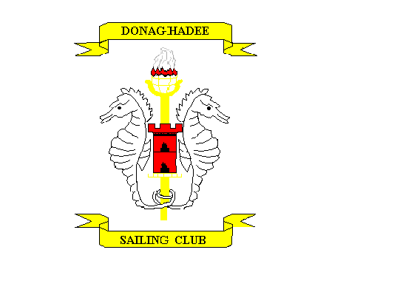
ADULT Course / Event Application Form 2019

Course / Event Type: __________________________Course Date: __________________________

Applicant’s Name: ___________________________________Date of Birth____________________

Address: ___________________________________________Post Code_____________________

Applicants Contact No._______________________ Email Address __________________________

Emergency contact::- Name ________________________Tel No. ___________________________

Club member - Yes / No Is applicant confident in the water - Yes / No

Present qualifications_______________________________________________________________

Medical Information. Any medical condition or disability. Yes / No (if Yes please give details)
________________________________________________________________________________

If course not booked and paid online at Club Website, then cheques made payable to Donaghadee Sailing Club for £____________________
Forms to - Training - Donaghadee Sailing Club, 20 Shore Street, D’Dee BT21 ODG

Data Protection

The Club has a data protection policy which is available on the Club website www.donaghadeesc.co.uk
The Club may wish to share data with the RYA in Northern Ireland, Sport NI (and their auditors ICONI and Knight, Kavanagh & Page)

If you consent to your data being shared in this way, please tick here.

The Club may take photographs or videos of activities and publish them on our website or social media to promote the Club

If you consent to your data being shared in this way, please tick here.

We will email you confirming the course joining information. If for some reason you do not hear from us then please email training@donaghadeesc.co.uk and we will deal with query.
I understand and agree with the terms and conditions (separate sheet) and agree to abide by them.

Signature of participant._________________________________________

For further information visit www.donaghadeesc.co.uk

Email training@donaghadeesc.co.uk or call Steve on 07595454065 or James on 07730006149

Club Use Only

Payment received CASH / CHEQUE / £ DATE _______________

Confirmation email YES/NO DATE _______________
Sailing Course/ Event - Terms & Conditions
- To register for a course simply complete the online application form and payment.
- An application form is also available on the Clubs website and should be posted along with your full payment to – Donaghadee Sailing Club, 20 Shore Street Donaghadee BT21 0DG.
- In the interests of planning, applications forms and payments, must be received no later than 7 days preceding the course.
- We will email you confirming the course joining information... If for some reason you do not hear from us or require any further information, then please email training@donaghadeesc.co.uk
- Please note that all courses require a minimum number of participants for them to run. In this unlikely event, we will provide a refund or offer an alternative suitable date. Refunds are not available under any other circumstances.
- For under 18s a parent or guardian needs to complete a Medical Consent Form and Junior Member Behaviour Code form on the first morning of the course or event.
- All children must be accompanied by a parent or guardian at the beginning and end of the session. Parents or guardians must also be contactable (for example by mobile phone) for the duration of the session.
- Neither DSC nor any of its instructors or agents shall be liable in any way whatsoever in respect of loss or damage to property.
- DSC must be informed, at the time of booking, of any medical condition affecting the participant, or of any medication taken by the participant that could affect their taking part in the above sailing session, e.g. asthma, epilepsy, heart conditions. DSC reserves the right to refuse any booking on medical grounds.
- All bookings are accepted on the understanding that any instructions or directions given by any member of the center’s staff are to be observed. Participants are asked to respect the equipment provided; compensation will be sought from anyone deliberately causing damage to equipment.
- DSC reserves the right at all times to refuse or restrict the use of facilities. The right is also reserved to evict anyone who refuses to comply with the conditions as stipulated, or who behaves inappropriately or, in any way, causes damage or annoyance to any other persons.
- Participants will be given a safety briefing by the instructor, which must be followed on or off the water:-
- If any injuries are sustained or damage to valuables occurs, participants are to notify the center’s staff immediately.
- Participants will be regarded as temporary Club members for the duration of the course.
- The Club has a data protection policy which is available on the Club website www.donaghadeesc.co.uk
The Club may wish to share data with the RYA and RYA Northern Ireland, Sport NI (and their auditors ICONI and Knight, Kavanagh & Page)
- The Club may take photographs or videos of activities and publish them on our website or social media to promote the Club. Please advise us if you wish to opt out.

